Guidance on Developing Provision for 2020/21
Course teams are advised to take a stepped approach to planning teaching and learning in 2020/21:
Step 1: Articulate pedagogical requirements;
Step 2: Consider possible solutions and select appropriate tools;
Step 3: Engage with staff development and training in new pedagogies and in the use of the selected tools.
This guidance relates to Step 1 of this process.

Articulating Pedagogical Requirements
When considering how to maximise student engagement in the new context, course teams should consider three things:
CURRICULUM
What students will be required to learn and how we will resource and assess this learning.
- Design inclusive learning opportunities to stimulate and challenge all students;
- Plan learning resources;
- Align assessment with these opportunities and resources.

LEARNING ACTIVITIES
What students will be required to do and how we will ensure they can do, and are doing, it.
- Structure learning through developmental, student-centred teaching;
- Enrich learning through building and maintaining a collaborative course community;
- Enhance learning through integrating regular dialogue and formative feedback

LEARNING ENVIRONMENT
What requirements students have and how we will enable and empower all students to succeed.
- Coherently organise the course;
- Proactively support individual students and their wellbeing;
- Empower students by enabling student input into course management and support.

Thinking about your Course in terms of Curriculum, Learning Activities and Environments
As a community we have been working for several years to develop expertise in these three areas, using the framework in Figure 1, and have developed and curated high-quality resources and guidance. The Wheel summarises how the components of a course fit together. The different rings (working from the inside out) show how a well-designed course provides scaffolded opportunities for students to engage. By thinking about our courses in terms of curricula, learning activities and learning environments (using the list above and/or the wheel) we can be confident that we are considering all aspects of course delivery. This way of thinking about a course can help us when planning to move from face-to-face to online learning.

Because the Wheel identifies what needs to be thought about and doesn’t refer to how we currently deliver a course (there is no reference to lectures, exams etc.), it can help us to think about different ways that we could achieve the same outcome. Our initial thoughts when moving to a new way of delivering may be to try to replicate how we currently work (e.g. putting a Panopto recording of a one-hour lecture online, uploading PowerPoint slides, or having students sit an online exam). However, simply replicating what we do may not be the most appropriate way for the new learning context in which our students find themselves. So, for example, by first considering the purpose and outcomes of the lecture, we can take advantage of opportunities to achieve these purposes and outcomes better suited to this new context. Once pedagogical requirements have been identified and articulated, a course team can consider possible solutions and select appropriate tools (Step 2).
Figure 1
Pedagogical Requirements of a Course: Curriculum, Learning Activities, Learning Environment
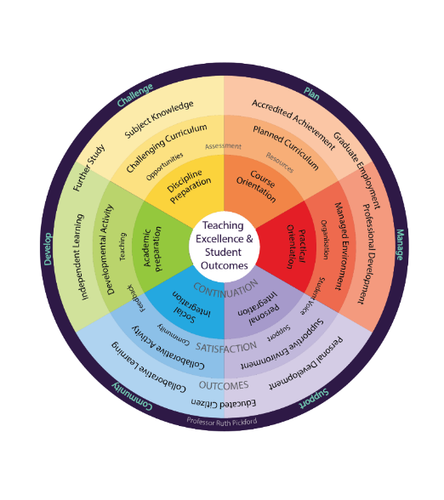
Collaborative, Developmental
Learning Activities
Teaching, Feedback, Course Community
A Managed,
Supportive
Learning Environment
Organisation, Support, Student Voice
Emotional engagement
Behavioural engagement
Conceptual engagement
A Planned, Challenging Curriculum
Learning Opportunities, Assessment, Resources

CLT Support for Articulating Pedagogical Requirements
Course teams may find the following CLT resources, which are being updated in May 2020, useful in articulating their pedagogical requirements:
Resource | CLT Contact
- The Course Development Principles | Professor Sue Smith
- The Wheel (curated resources and case studies organised according to the wheel - above) | Becky Sellers
- The DEAP Educational Development Programme (DEAP20 conference, networks, fora, sessions, development opportunities) | Georgi Sinclair
CLT May 2020

